Pre Calc Name: ______________

______________ ______________

WS Assessment

Target 18

Parametric and polar equation

* Rotation of Conics
* Parametric Equations
* Graphs of Polar Equations
* Functions in Polar Coordinates and their Graphs
* Polar Equations of Conics.

HW 18 Parametric and Polar deltamath.com

**Rotation of Conics**: We have learned about a conic with axes parallel to one of the coordinate axes which has a standard form Ax2 + Cy2 + Dx + Ey + F = 0. Now we extend our study to the equations of conics whose axes are rotated so that they are not parallel to either the -axis or the -axis. The general equation for such conics contains an xy-term.

Ax2 + **Bxy** + Cy2 + Dx + Ey + F = 0

To eliminate this xy-term, we use a procedure called rotation of axes. The rotated axes are denoted as the x’-axis and y’-axis $\tan\left(2x\right)=\frac{2 tan⁡(x)}{1-\tan^{2}x}$

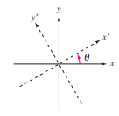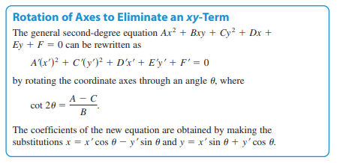

Write the ellipse $7x^{2}-6\sqrt{3}xy+13y^{2}-16=0$ in standard form, then sketch

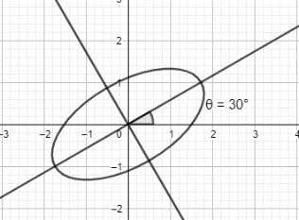A = 7 B = - $6\sqrt{3}$ C = 13, D = E = 0 F = -16

$\cot{θ=\frac{A-C}{B}}=$ therefore $θ=?$ $x=x^{'}\cos{30}-y^{'}\sin{30}=$?

$y=x^{'}\sin{30}-y^{'}\cos{30}=$?

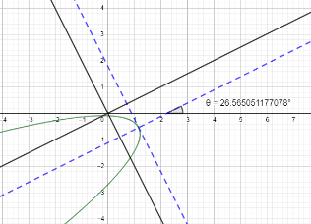Write the parabola $x^{2}-4xy+4y^{2}+5\sqrt{5}y+1=0$ in standard form, then sketch. Stamp (desmos ok)

A = B = C = D = E = F = $θ=?$

**Parametric equation**

A person jumps from the building at 10 feet high to

the ground. His landing position can be found by a

parabola equation f(x) = 10 – x2.

On a window of (0, 10) by (0, 10) sketch the fly and

the landing position (how far from the building).

Now the rescue team is running toward the building and try to catch the young men. If they are 10 feet away from the building and run with the velocity of 3ft/second, can they reach the landing position in time for rescuing? Explain your reasoning here

This type of problem requires your knowledge of parametric equation.

Let switch your graphing calculator to parametric function (MODE, PAR)

Hit Y= to enter the function as follow X1 = T Y1 = 10 – T2

Press Window Tmin = 0 Tmax = 4 Tstep = 1/32 (gravity 32 ft/s2)

Keep the rest the same as (0, 10) by (0, 10) Now press graph.

You should see how the “person” is falling to the ground

Let go back to the Window and change Tmax to 2. Press graph, you see the falling person is not reach to the ground. Why?

Now, adjust your Tmax again to figure out the time that need for a person just to touch the ground, no more, no less. Tmax = ? _________

Back to the problem. We have just recreated the situation of a young men jump off the top of the building to experience the short test road that leads to heaven. Now, the rescue team running toward the building in negative direction with the catcher of 2 feet high and velocity is 3ft/s, we have X2 = 10 - 3T Y2 = 2 . Make sure, your calculator in simulation mode (MODE, SIMUL)

Will the rescue team able to rescue the “out of love” boy? __________________

Should they run faster or slower to get the man?

Show me the speed that need from the rescue team to get the stamp ________________

2. Consider a projectile launched at a height of h feet above the ground at an angle θ with the horizontal. If the initial velocity is vo feet per second, the path of the projectile is modeled by the parametric equations x = (vocos θ)t and y = h + (vo sin θ)t-16t2.  
The center-field fence in a ballpark is 25 feet high and 400 feet from home plate. The baseball is hit 4 feet above the ground. It leaves the bat at an angle of 20 degrees with the horizontal at a speed of 100 miles per hour.  
Use Tstep = 1/32 to figure how long the ball “hang” in the air and the position of its landing.

Now let say the catcher is standing from the end of the field which is 400 feet away and start to run toward to catch the ball. Figure out the minimum speed he has to run in order to catch the ball. In reality he can either catch the ball standing or lying (this is your choice).

Write the answer here _______________________ and show me the simulation on your graphing calculator (just at the right moment) to get a stamp _____________________________

Converting problem

1. Convert to parametric from Cartesian (there are lot of way to write it)

a. y = 2x – 2 b. y = 2x2 – 3x + 2 c. 3x – 4y + y2 = 0

2. Covert to Cartesian from Parametric

a. x = t + 1 b. x = t2 c. x = et

y = t2 + 2t y = t – 2 y = 2t2

d. Find parametric equations for the line y = 2t – 5 segment from point (2, -1) to (6, 5). Stamp

Graph the following parametric equations and write their name. AxesOff, choose best Windows t

|  |  |  |  |
| --- | --- | --- | --- |
| x = t – sin t  y = 1 – cos t | x = 5cos t  y = 2sin t | x = cos t  y = sin 2t | x = cos t – cos 2t  y = sin t – sin 2t |
| x = cos 5t  y = sin t | x = cos t – cos 10t  y = sin t – sin 10 t | x = 2t + 3 sin 7t  y = t + 8 cos 3t | Your beautiful here.  Stamp |

This is mine x = 2sin3 t ; y = 4cos t – 5cos 2t – 6cos 3t – 7cos 4t

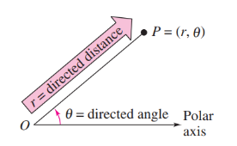Polar equation

Change mode to polar and graph r = 3. You will have a circle radius 3.

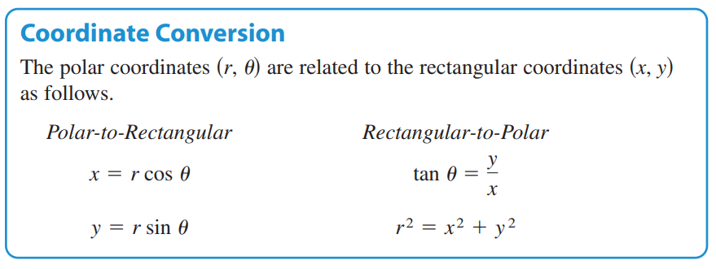

Polar r = 3

Rectangle x2 + y2 = r2 = 9

Convert y = x2 to polar form Convert r = sec θ to rectangular form

graph both mode for stamp graph both mode for stamp

Convert to rectangular Convert to polar

a. r = sin 4θ b. r + 2sinθ = 0 c. x2 + y2 – 4y = 0 d. x2 /9 + y2 /4 = 1

Special Polar Graphs

1. Circle Family r = a sin θ and r = a cos θ

|  |  |
| --- | --- |
| r1 = 5sinθ; r2 = 8sinθ; r3 = 10sin θ  Graph and locate the center and radius for each circle | r1= 5cosθ; r2 = 8cosθ ; r3 = 10sinθ  Graph and locate the center and radius for each circle |

2. Rose Family r = a sin (bθ) and r = a cos(bθ) where b > 2 . Sketch 6 graphs (separate)

|  |  |
| --- | --- |
| r = 5sin2θ; r = 6sin2θ; r = 7sin2θ | r = 5cos3θ ; r = 5cos4θ; r = 5sin5θ |

What is the difference between sin graph and cos graph?

What factor to create more petal of the rose?

Can you guess how many petals for this rose? y = 10 sin (25θ) ?____________

3. Limaçons of Pascal family r = a ± b sin θ and r = a ± b cos θ

(You fill in with value for a and b)

|  |  |  |  |
| --- | --- | --- | --- |
| Inner loop if a < b | Cardioid if a = b | Dimpled if b < a < 2b | Convex if b > 2a |
| Archimedean Spiral  r = θ | Cissoid of Diocles  r = a sinθ tanθ | Folium of Descartes $$r=\frac{3asinθcosθ}{\sin^{3}θ\cos^{3}θ}$$ | Lemniscates  r2 = a2 sin (2θ) or  r2 = a2 cos (2θ) |

**Target 18 Assessment**

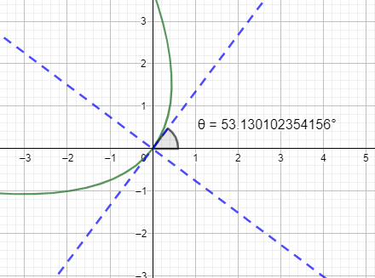Write the parabola ${9x}^{2}+24xy+16y^{2}+80x-60y=0$

in standard form, then sketch. Stamp (desmos ok)

Graph a circle center (3,4) radius 5 in three types of graph: rectangular, parametric, and polar

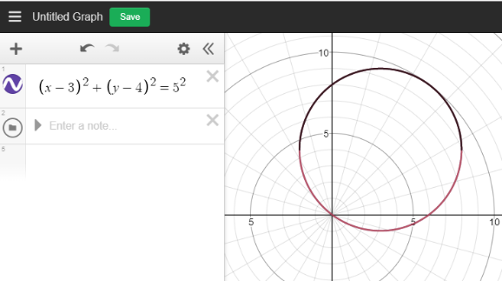Desmos ok. Stamp